

Special Techniques Group

Building D4/05

Culham Centre for Fusion Energy

Abingdon

Oxfordshire, OX14 3DB

Direct Line: 01235 466777

|  |  |  |  |
| --- | --- | --- | --- |
| **Date:** |  | | |
| **STG job number:** | **Q20xxx** | | |
| **Customer:** |  | | |
| **Organisation:** |  | | |
| **Assembly ID:** | **01** | **Quantity:** | **1** |

Many thanks for your recent enquiry for the manufacture and supply of bespoke re-entrant viewports.

It would assist greatly in the quotation process if you could fill out the following tables to confirm your critical viewport parameters (If your constrained dimension is not labelled, please include any additional constraints in the blank spaces provided). Please fill out a separate response form for each unique assembly and indicate the quantity required above.

It is preferred to leave any non-critical dimensions blank, or include a range where there is a loose constraint, to allow some design freedom. Any unspecified dimensions will be confirmed after receipt of order in the final design drawings.

An ordering timeline indicating the actions of all parties is included below to clarify the ordering process. Our standard terms and conditions are also included for reference.

|  |  |  |
| --- | --- | --- |
| **End User Statement** | Brief statement of end use regarding R&D, scientific experiment, medicine, military use, industrial production etc | |
|  | | |
| Is this assembly for military use: | |  |
| Please confirm you have read the Terms & Conditions (STG_ADM_016 B) below: | |  |

Ordering timeline

|  |  |
| --- | --- |
| **Party** | **Action** |
| Customer | Initial inquiry |
| STG | Confirm feasibility and provide Inquiry Response |
| Customer | Provide design criteria on Inquiry Response |
| STG | Provide quotation based on design criteria |
| Customer | Place purchase order |
| STG | Provide final design drawings for customer review |
| Customer | Confirm acceptance of design |
| STG | Manufacturing begins |

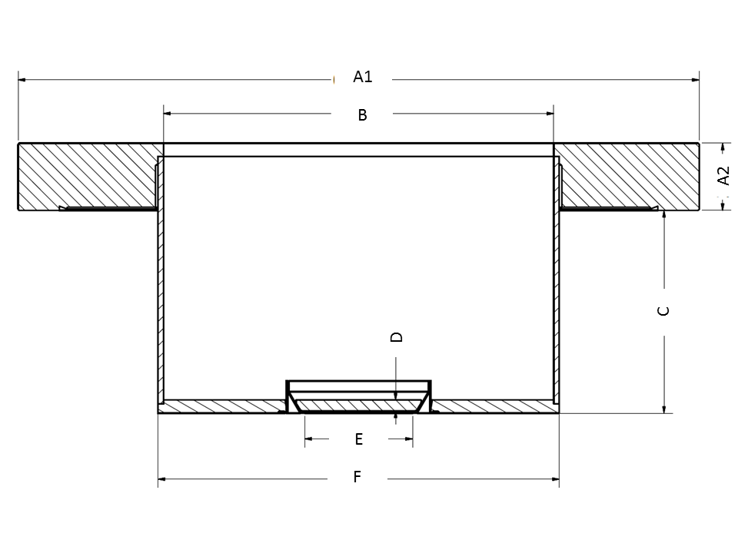

Figure 1: Viewport typical dimensions

Table 1 - Geometric

|  |  |  |  |
| --- | --- | --- | --- |
| **Label** | **Content** | **Example** | **Customer Requirement** |
| A1,2 | Vacom CF Flange | DN100CF |  |
| B | Tube ID | 66 mm |  |
| C | Flange exterior to endplate* | 41 mm |  |
| D | Optic thickness | 6 mm |  |
| E | Optic clear view (CV) aperture | 60 mm |  |
| F | Tube OD | 70 mm |  |
|  |  |  |  |

*See standard constraints in table below, these design rules can be relaxed on request, but it will likely result in greater risk and cost*

*\* Note the optic is recessed slightly from the end of the tube (as mentioned in constraint 10), please mention if the optic position requires tight control*

Table 2 - Constraints

|  |  |  |
| --- | --- | --- |
| **Constraint** | **Content** | **Standard/Limit** |
| 1 | ((F – B) / 2) Tube wall thickness | Min. 2 mm |
| 2 | Tube endplate thickness | Min. 5 mm |
| 3 | (E) Standard optic clear view (CV) aperture sizes | 7, 14, 24, 29.5, 38, 40, 44, 50, 60, 73.2, 87.7, 95, 126, 140, 160 mm |
| 4 | (D) Optic thickness, 7cv – 50cv | Min. 5 mm |
| 5 | (D) Optic thickness, 60cv – 73.2cv | Min. 6 mm |
| 6 | (D) Optic thickness, 87.7cv – 95cv | Min. 8 mm |
| 7 | (D) Optic thickness, 126cv – 140cv | Min. 10 mm |
| 8 | (D) Optic thickness, 160cv | Min. 17 mm |
| 9 | (C) Re-entrant length | Max. 200 mm |
| 10 | Optic recess from endplate | ~0.7 mm |
| 11 | (F – E) Optic support structure | 20 mm |

Table 2 - Material

|  |  |  |
| --- | --- | --- |
| **Material Parameters** | **Standard** | **Special Customer Requirement** |
| Flange and metalwork | Stainless Steel 316 |  |
| Optic ferrule | Inconel 625/Tantalum |  |
| Optic material | Fused Silica  (Hereaus Spectrosil 2000) |  |
| Optic flatness (TWE) * | Transmitted Wavefront Error (TWE) PV: Lambda/8 |  |
| Optic parallelism (tilt) | < 3 arc minutes |  |
| Optic polish * | 80/50 Scratch/Dig |  |
|  |  |  |

*\* Optic finish parameters are measured before bonding. No optic parameters can be guaranteed after bonding except in the case of specific development and inspection trials. Optic properties are specified over 90% aperture (clear view)*

Table 3 - Anti-Reflection (AR) coating

|  |  |  |
| --- | --- | --- |
| **Coating Parameters** | **Standard** | **Customer Requirement and maximum R tolerance** |
| Double-sided | Yes |  |
| Angle of Incidence | 0 degrees |  |
| Wavelength 1  (In order of priority) | e.g. 400nm, R_max 1% |  |
| Wavelength 2 | - |  |
| Wavelength 3 | - |  |
| Wavelength 4 | - |  |
|  |  |  |

|  |
| --- |
| **Additional details / sketches** |
|  |

With kind regards,



Martin Cuddy

Special Techniques Group

